POS: Design and Critical Analysis of a Multi-Store Point-of-Sale Platform
Role-based access, branch-level inventory, refund and shift accounting, analytics, and subscription billing
Vrushay Bohra  Student  Computer Science Engineering  Arya College of Engineering and I.T. | Vishvas Choubisa  Student  Computer Science Engineering  Arya College of Engineering and I.T. | Subhash  Student  Computer Science Engineering  Arya College of Engineering and I.T.
Tanya Singh  Student  Computer Science Engineering  Arya College of Engineering and I.T. | Vimal Kumar  Student  Computer Science Engineering  Arya College of Engineering and I.T. | Mr. Ram Babu Buri  Project Guide  Computer Science Engineering  Arya College of Engineering and I.T.

Abstract—Retail businesses that operate several branches need one system that records sales, controls stock, supervises staff, handles refunds and reports performance, while keeping each business’s data isolated from every other. This paper analyses the design of the Point-of-Sale (POS) System as documented in its project notes: a Spring Boot REST backend with JPA/Hibernate persistence, Spring Security with JSON Web Tokens (JWT) and a web client. By this paper’s count the notes document 17 backend modules, about 105 endpoints, 13 principal domain entities and a six-level role hierarchy spanning platform, store and branch scope. We (i) reconstruct the architecture and domain model, (ii) audit the notes for internal inconsistencies and security-relevant gaps, producing a register of 16 findings, and (iii) propose a target design for tenant isolation, transactional checkout, refund integrity, reporting definitions and subscription lifecycle, together with a verification plan. The notes contain no benchmarks, test results or user studies; every claim here is therefore a statement about design, labelled as documented, inferred or recommended, and no performance or business-impact claim is made.
Index Terms—Point-of-sale, multi-tenant SaaS, role-based access control, JSON Web Token, Spring Boot, inventory management, refund accounting, retail analytics, subscription billing.
1. INTRODUCTION
A point-of-sale (POS) system began as an electronic cash register. Today a retail POS is an operational platform: it holds the product catalogue, tracks stock per location, records customers and staff activity, reconciles cashier shifts and feeds dashboards. When the vendor serves many independent businesses (a multi-tenant software-as-a-service model), each business may in turn run several branches, so correctness depends as much on who may see and change what as on arithmetic at the till.
The POS project notes [1] describe such a platform end to end, from cashier terminal to super-admin dashboard. They are written as teaching material (one section is titled “Explain to Students”, p. 10), which makes them a useful, compact reference design but also explains why they are uneven: some modules are fully specified, others are headings only.
Research questions. RQ1: What functional scope, architecture and domain model do the notes describe? RQ2: Where is the documented design internally inconsistent, incomplete or risky? RQ3: What target design and verification plan would make it suitable for production use?
Contributions. (1) A structured reconstruction of the system from the notes; (2) a quantified inventory of its API surface; (3) a findings register tied to page references; (4) a target design for the highest-risk areas; and (5) a measurable verification plan.
2. BACKGROUND
POS and billing studies. Published POS studies show what such systems are expected to deliver and how they are evaluated. Mangmang [2] built a retail POS that notifies users of overdue payments and out-of-stock items and evaluated it against ISO/IEC 25010 with a questionnaire. Natividad et al. [3] studied acceptance of cloud-based POS for inventory management among micro food businesses, Hidayati et al. [4] analysed POS implementation in a coffee shop, Umar et al. [5] tested an RFID-based supermarket self-billing system, and Zolbanin et al. [6] examined cloud ERP for small and medium enterprises. These works concentrate on a single enterprise or outlet; none addresses the tenant-isolation and branch-accounting problems studied here.
Multi-tenancy. SaaS data can be isolated by separate databases, separate schemas, or a shared schema with a tenant discriminator column [7], [8]. Shared-schema designs are the cheapest to operate but place the whole burden of isolation on application code: one missing filter leaks another tenant’s data [9]. The design analysed here is shared-schema, using store and branch foreign keys as discriminators (Section 5.3).
Access control. Role-based access control (RBAC) assigns permissions to roles rather than individuals [10], [11], [12]. RBAC alone answers “may a cashier create orders?”, not “may this cashier read that order?”. The latter, object-level authorisation, is the most common serious API flaw: Broken Object Level Authorization is ranked first in the OWASP API Security Top 10 (2023) [13].
Token authentication. JSON Web Tokens (JWTs) [14] let a stateless API authenticate each request, but they are bearer credentials: signing-key management, algorithm choice, expiry and revocation determine real security [15].
Layered service design. The controller, service and repository structure, Data Transfer Objects (DTOs) and the Service Layer pattern separate HTTP concerns from business rules and persistence [16], [17]. Business invariants (stock never negative, refunds never exceeding sales) belong in the service layer and the database, not in the client.
Money and concurrency. Binary floating point cannot represent most decimal fractions exactly, so currency should use fixed-precision types [18]. Concurrent checkouts require explicit transaction and isolation design to avoid lost updates and overselling [19].
3. METHOD AND EVIDENCE LABELS
The study is a document analysis of the supplied notes (dependency list, models, controller tables and prose). Each statement is tagged as shown in Table I.
TABLE I
EVIDENCE LABELS
Label | Meaning
[D] Documented | Stated directly in the notes; page cited.
[I] Inferred | A reasonable reading of the notes, not stated.
[R] Recommended | Design guidance by the authors of this paper; not a claim about the system.

Endpoint counts are tallied from the controller tables of the current model generation (Section 6.2). Two parts of the notes are empty headings (“Payment Service”, “Email Service”, p. 25) and the final page is blank (p. 26); nothing is assumed about their content. The notes do not name the front-end framework, so none is assumed.
4. SYSTEM OVERVIEW
4.1 Actors
TABLE II
ACTORS AND DOCUMENTED RESPONSIBILITIES
Actor | Scope | Documented responsibilities
Super Admin | Platform | Moderate stores, manage subscription plans, platform dashboards (pp. 10, 21, 24)
Store Admin | Store | Owns store, branches, employees, store analytics, subscription
Store Manager | Store | Employees, categories, inventory (pp. 10, 14, 15)
Branch Admin / Manager | Branch | Branch employees, recent orders, branch analytics (pp. 16, 19)
Cashier | Branch | Create orders, process refunds, run shifts (pp. 18–21)
Customer | Store (record only) | A data record attached to orders; not a login user

4.2 Feature coverage
The feature list (p. 1) is broader than the documented backend. Table III maps features to evidence.

TABLE III
FEATURE COVERAGE AGAINST EVIDENCE IN THE NOTES
Feature | Backend evidence in notes | Status
POS terminal, cart | Orders API; cart logic not described | [I] client-side cart
Product search | /api/products/store/{storeId}/search (p. 12) | Documented
Create order, order history | Orders API (p. 18) | Documented
Customer management | Customers API (p. 17) | Documented
Discounts | No field on Order/OrderItem; “tax & discount logic” listed as future work (p. 9) | Listed only
Download bill | “Optional PDF or HTML view” (p. 8) | Listed only
Shift summary | Shift Report API (pp. 20–21) | Documented
Refunds | Refund API (p. 19) | Documented
Inventory | Inventory API (pp. 15–16) | Documented
Sales and report charts, dashboards | Branch, store and admin analytics (pp. 21–23) | Documented
Store onboarding | Store create and moderate (p. 10) | Documented
Subscriptions | Plan and subscription APIs (pp. 23–25); payment service empty | Partly documented
Login | /auth/login (p. 4) | Documented
Forgot password | No endpoint or token model | Listed only
Dark/light theme, landing page | Front-end concerns | Listed only

5. ARCHITECTURE
5.1 Layered structure

Fig. 1 shows the request path. The client sends HTTPS requests with an Authorization: Bearer header; the security filter chain validates the JWT, populates the security context and applies role checks; controllers bind DTOs and validate requests; services hold business rules and transactions; mappers and Spring Data JPA repositories convert and persist entities in a relational database. Mail and the Razorpay and Stripe SDKs are side services. The backend is built on Spring Boot, Spring Security and Spring Data JPA [20].

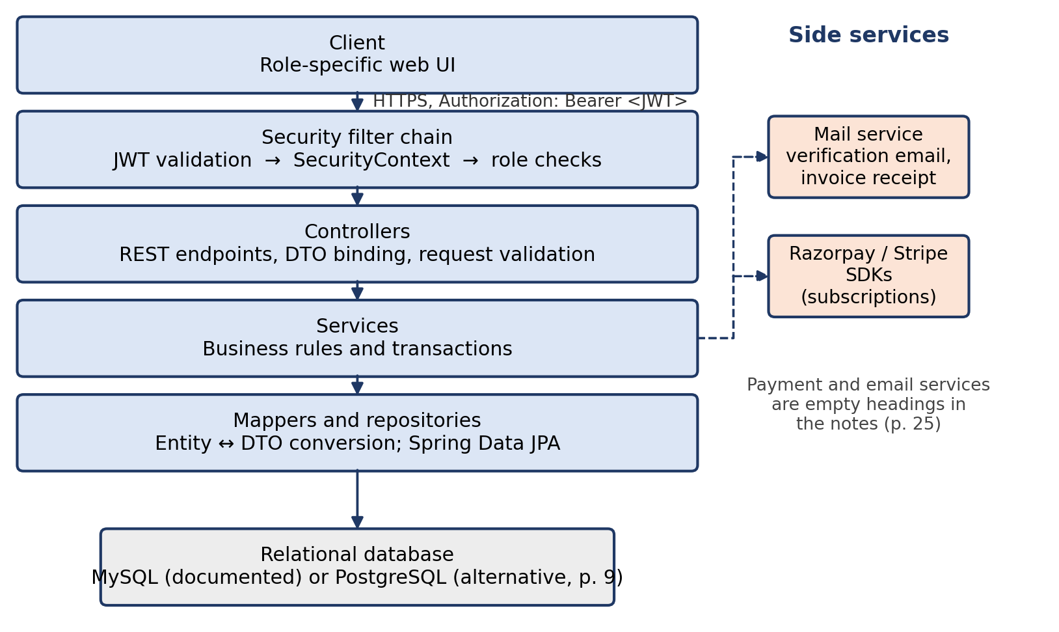
Fig. 1. Layered architecture as documented in the notes, with side services.
5.2 Technology stack [D, pp. 2–3, 9]

TABLE IV
TECHNOLOGY STACK DOCUMENTED IN THE NOTES
Concern | Technology
API | Spring Boot, spring-boot-starter-web (REST over Spring MVC)
Persistence | spring-boot-starter-data-jpa (JPA/Hibernate), mysql-connector-j
Security | spring-boot-starter-security, JJWT (jjwt-api, -impl, -jackson), BCrypt
Validation | spring-boot-starter-validation (@NotNull, @Email)
Messaging | spring-boot-starter-mail (verification email, invoice receipt)
Payments | razorpay-java, stripe-java
Testing | spring-boot-starter-test (JUnit, Mockito), spring-security-test, Postman
Developer tooling | Lombok, DevTools, Swagger (optional), Maven plugin

5.3 Tenancy model
The design is shared schema with discriminator columns [I]. Tenant scope flows through foreign keys: users, branches, categories and products reference a store; inventory, orders, refunds and shift reports reference a branch (which references a store). Customers carry no store or branch reference (p. 17), the one entity that breaks the pattern (Finding F6).
6. DOMAIN MODEL
6.1 Entities and relationships [D, pp. 4–24]
Table V lists the 13 principal entities documented in the notes, and Fig. 2 sketches their relationships.

TABLE V
ENTITIES, KEY ATTRIBUTES AND RELATIONSHIPS
Entity | Key attributes | Relationships
User | name, email (unique), password hash, phone, role, verified, lastLogin | many-to-one Store, Branch
Store | brand, type, description, status (PENDING/APPROVED/DECLINED), contact | storeAdmin (User)
Branch | name, address, phone, email, workingDays, open/close time | many-to-one Store; one-to-one manager (User)
Category | name | many-to-one Store
Product | name, SKU, description, MRP, sellingPrice, brand, image | many-to-one Category, Store
Inventory | quantity, lastUpdated | many-to-one Branch, Product
Customer | fullName, email (not unique), phone | none
Order / OrderItem | totalAmount, paymentType, createdAt; item: product, quantity, price | Branch, cashier (User), Customer; one-to-many items
Refund | reason, amount, paymentType, createdAt | Order, cashier, Branch, ShiftReport
ShiftReport | start/end, totalSales, totalRefunds, netSales, totalOrders | cashier, Branch; refunds, orders
SubscriptionPlan | price, billingCycle, max branches/users/products, feature flags | none
Subscription | start/end date, status, gateway, transactionId, paymentStatus | Store, Plan

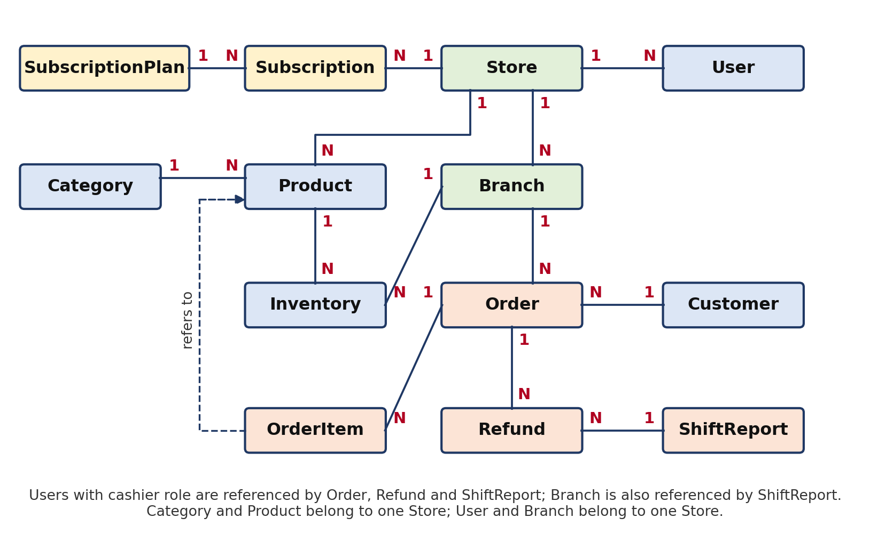
Fig. 2. Domain model of the principal entities (1 = one, N = many). In the notes, Customer carries no store or branch reference (Finding F6).
6.2 Two generations of the model

The notes contain an early “Backend Documentation” (pp. 3–9) and later per-module documentation (pp. 9–25) that disagree: early Product holds price, quantity and barcode; later Product holds sku, mrp, sellingPrice, store and category. Early Sale/SaleItem (/api/sales) became Order/OrderItem (/api/orders); early Inventory (productId, quantityAdded, currentStock) became a branch-and-product quantity record. This paper treats the later generation as current. The older model also contains a good idea worth keeping: quantityAdded plus currentStock is the seed of a stock-movement ledger (Section 8.3).
6.3 Design observations
• Catalogue at store level, stock at branch level is the right split: one product definition, many stock positions. [D/I]
• Price snapshots. Order items store a price, which correctly freezes the sale price independent of later catalogue edits. [D]
• Missing constraints. The notes state no uniqueness for (branch, product) in Inventory or (store, SKU) in Product. [D, absence]
7. API DESIGN ANALYSIS
7.1 Surface area
Table VI tallies the endpoints of the current model generation: 17 modules and about 105 endpoints. The superseded early endpoints (products, inventory, sales) add 8 more, giving about 113 listed in all.
TABLE VI
API SURFACE BY MODULE (CURRENT GENERATION)
Module | Base path | Endpoints
Auth | /auth | 2
User | /api/user, /api/users | 2
Store | /api/stores | 10
Category | /api/categories | 4
Branch | /api/branches | 5
Product | /api/products | 6
Inventory | /api/inventories | 6
Employee | /api/employees | 7
Customer | /api/customers | 5
Order | /api/orders | 8
Refund | /api/refunds | 8
Shift report | /api/shift-reports | 9
Super-admin dashboard | /api/super-admin/dashboard | 3
Branch analytics | /api/branch-analytics | 6
Store analytics | /api/store/analytics | 10
Subscription plan | /api/super-admin/subscription-plans | 5
Subscription | /api/subscriptions | 9
Total |  | ≈ 105

7.2 Conventions and observations
• Resource-oriented paths with standard verbs are used consistently. Store moderation is a PUT with a query parameter (?action=APPROVED, p. 10); a dedicated sub-resource or verb endpoint with an audit record would be clearer. [R]
• Product update is PUT in the early notes and PATCH in the later notes (pp. 6, 12). [D]
• List endpoints (GET /api/customers, /api/refunds, /api/shift-reports) show no pagination, filtering or sorting contract. [D, absence]
• Error handling is described only for products (UserException, AccessDeniedException, p. 13). A uniform error body and status-code policy is not documented. [D, absence]
• Identity is frequently passed in the path ({storeAdminId}, {cashierId}) rather than derived from the token (Finding F7).
8. TRANSACTIONAL INTEGRITY [R UNLESS STATED]
8.1 Checkout
The notes define order entities and a POST /api/orders endpoint restricted to cashiers (p. 18) but not the transaction logic. A dependable checkout would:
1. Derive cashier, branch and store from the authenticated principal, never from the request body.
2. Open one database transaction.
3. Load requested products and reject any outside the cashier’s store.
4. Take prices from the database, not the client, and compute discounts, tax and totals with fixed-precision decimals.
5. Decrement stock with a conditional update; zero rows updated means rollback with a conflict response.
6. Persist the order and items, with price, discount and tax snapshots and a client-supplied idempotency key.
7. Commit; then trigger receipt, email and reporting roll-ups asynchronously.
UPDATE inventory
SET quantity = quantity - :qty,
last_updated = NOW()
WHERE branch_id = :branch
AND product_id = :product
AND quantity >= :qty;
-- 0 rows affected => insufficient
-- stock => rollback

This single statement is atomic under concurrent requests, so two cashiers selling the last unit cannot both succeed [19]. Optimistic locking (a version column) is an alternative where read-modify-write is unavoidable.
A further observation: gateway SDKs appear in the notes in connection with subscriptions (paymentGateway, transactionId), whereas orders carry only a paymentType label (CASH/CARD/UPI). In-store card and UPI payments are therefore probably recorded manually rather than captured through a gateway. [I]
8.2 Money
Every monetary field in the notes is Double (pp. 6, 7, 11, 17, 19, 20, 23). Totals, refunds and shift aggregates should use BigDecimal mapped to DECIMAL(12,2), or integer minor units, with an explicit rounding mode [18].
8.3 Stock as a ledger
Adopt an append-only stock_movement table (SALE, REFUND_RESTOCK, PURCHASE, ADJUSTMENT, with signed quantity, reason, actor and reference id). Current quantity becomes a cached sum and every discrepancy becomes explainable. This generalises the early quantityAdded/currentStock design.
8.4 Refunds
The documented Refund holds only an order, a reason and an amount (p. 19). Recommended invariants: refund amount must not exceed the order total minus prior refunds; refunds reference order items so partial and per-item returns are representable; restocking is an explicit choice; refunds are append-only and never alter the original order; and large refunds require manager approval.
8.5 Shift lifecycle
The notes say a shift helps track “cash handling” (p. 20), yet ShiftReport has no opening float, expected cash, counted cash or variance. Add these fields, enforce at most one open shift per cashier (for example a partial unique index on cashier where shift_end IS NULL), and prefer computing aggregates from orders and refunds at close, then freezing them.
8.6 Deletion
DELETE is offered on orders, refunds and shift reports (pp. 18–21). Hard deletion of financial records destroys the audit trail. Replace it with status transitions (VOIDED, CANCELLED) and soft delete, restricting any physical purge to retention jobs.
9. SECURITY ANALYSIS
The notes document BCrypt hashing [21], JWT issuance on login, “all routes secured except /api/auth/**”, and role checks (pp. 4, 9). Table VII lists the risks that the documented design leaves open; each requires confirmation against the implementation.

TABLE VII
THREATS, EVIDENCE IN THE NOTES AND RECOMMENDED MITIGATIONS
# | Threat | Evidence in notes | Mitigation [R]
T1 | Cross-tenant object access (BOLA) | IDs in paths for orders, refunds, shifts, analytics; no ownership check documented | Resolve every ID through a tenant-scoped query (WHERE store_id = :principalStore); test with two tenants
T2 | Unauthenticated data exposure | Five order read endpoints and one category read marked Public (pp. 14, 18) | Require authentication and scope for all order reads; allow public catalogue only if intentional
T3 | Privilege escalation at signup | /auth/signup registers “admin, cashier” (p. 4) | Ignore role in request; self-signup creates only a store-admin pending moderation; staff are created by authorised users
T4 | Mass assignment | Customer service takes the Customer entity directly (p. 17) | Bind to request DTOs with explicit fields
T5 | Token weaknesses | Expiry, algorithm, key storage, revocation not documented | Short-lived access tokens, strong signing key from a secret store, pinned algorithm, refresh-token rotation [15]
T6 | Credential attacks | Login endpoint documented without throttling | Rate limiting, lockout or backoff, generic error messages
T7 | Payment tampering | Manual payment-status override and activate endpoints (p. 25) | Drive state only from verified gateway webhooks [22]; restrict and audit overrides
T8 | Personal data | Customer name, email, phone stored (p. 17) | Data minimisation, retention policy, and review under applicable law (for India, the DPDP Act, 2023 [23])
T9 | Secrets and transport | Mail, JWT, DB and gateway credentials will exist | Externalised configuration, HTTPS only, no secrets in source control

Proposed permission matrix [R]

The notes use at least three role vocabularies (Finding F4). A single scope-based matrix (Table VIII), enforced server-side, would replace them. Cell values give the scope of access.

TABLE VIII
PROPOSED PERMISSION MATRIX (SCOPE OF ACCESS)
Operation | Super Admin | Store Admin | Store Mgr | Branch Admin | Branch Mgr | Cashier
Moderate stores; manage plans | All | — | — | — | — | —
Subscribe / upgrade | — | Store | — | — | — | —
Manage branches | — | Store | Store | — | — | —
Manage employees | — | Store | Store | Branch | Branch | —
Manage catalogue | — | Store | Store | — | — | —
Read catalogue | — | Store | Store | Store | Store | Store
Adjust inventory | — | — | Store | — | Branch | —
Create order | — | — | — | — | — | Branch
View orders | — | Store | Store | Branch | Branch | Own
Refund | — | — | Approve | Approve | Approve | Initiate
View analytics | Platform | Store | Store | Branch | Branch | —

10. ANALYTICS AND REPORTING

The notes document 19 analytics endpoints across three audiences: platform (store counts, registrations over 7 days, status distribution), branch (daily sales, top 5 products with percentage share, top 5 cashiers by revenue, category sales, today’s overview, payment breakdown), and store (overview, daily, monthly and weekly trends, category and payment splits, per-branch sales and performance, alerts such as low stock and inactive cashiers) (pp. 21–23).
Dashboards are only trustworthy if metrics are defined once. Table IX gives the proposed definitions [R].
TABLE IX
PROPOSED METRIC DEFINITIONS
Metric | Definition
Gross sales | Sum of completed order totals in the period
Refunds | Sum of refunds created in the period (reported against the refund date)
Net sales | Gross sales − refunds (the notes’ own definition, p. 20)
Reporting day | Store-local calendar day, using the store’s time zone
Excluded | Voided or cancelled orders
Top products | By quantity, with share = product quantity ÷ total quantity

For scale, index orders on (branch_id, created_at), maintain a daily per-branch roll-up table, and read dashboards from roll-ups rather than scanning orders. Every analytics query must be tenant-scoped; store analytics should derive the store from the token rather than a {storeAdminId} path value. The notes also show a terminology mismatch: stores are PENDING/APPROVED/DECLINED (p. 10) but the admin dashboard counts “active, pending, blocked” (p. 21).
11. SUBSCRIPTION AND PLAN ENFORCEMENT
Plans define price, billing cycle, limits (branches, users, products) and feature flags (advanced reports, inventory, integrations, e-commerce, invoice branding, priority support, multi-location) (pp. 23–24). Subscriptions carry status TRIAL, ACTIVE, EXPIRED or CANCELLED and a payment status (p. 25). Limits and flags have no value unless enforced at the service layer at the moment of use, for example refusing branch creation beyond maxBranches or hiding inventory endpoints when enableInventory is false. [R] Table X shows a proposed lifecycle.
TABLE X
PROPOSED SUBSCRIPTION LIFECYCLE
From | To | Trigger
(none) | TRIAL | Store approved by super admin
TRIAL / EXPIRED | ACTIVE | Verified gateway webhook reports payment success
ACTIVE | ACTIVE (new plan) | Upgrade with proration rule
ACTIVE | EXPIRED | End date passes without renewal (after grace period)
Any | CANCELLED | Admin or store request

Webhook handling must verify the gateway signature, be idempotent on transactionId, and tolerate out-of-order delivery [22].
12. FINDINGS REGISTER
The audit of the notes produced sixteen findings (Table XI). Severity is a judgement based on common practice [13], [15], [18]; evidence refers to pages of the notes.

TABLE XI
FINDINGS REGISTER
ID | Finding | Evidence | Severity | Recommendation
F1 | Two inconsistent generations of the domain model | pp. 6–8 vs 11–19 | Medium | Declare one canonical model; retire early notes
F2 | Signup may accept a privileged role | p. 4 | High | Server-assigned roles only
F3 | Auth path is /auth/** in tables but /api/auth/** in security rules | pp. 4, 9 | Medium | Align routes and security matcher
F4 | Role names inconsistent (ADMIN/CASHIER/MANAGER, ROLE_STORE_*, STORE_MANAGER, prose) | pp. 4, 5, 10, 11, 15 | Medium | Single enum and permission matrix
F5 | Order and category reads marked Public | pp. 14, 18 | High | Authenticate and scope
F6 | Customers not tenant-scoped; list returns all; email not unique | pp. 16–17 | High | Add store reference; scope all queries
F7 | Identity and scope taken from path IDs | pp. 18–23 | High | Derive from JWT; verify ownership
F8 | Double for all money | pp. 6–23 | High | BigDecimal / DECIMAL
F9 | No documented atomic stock deduction or unique (branch, product) | pp. 15, 18 | High | Conditional update; unique key; ledger
F10 | Order lacks status, discount and tax fields yet status filter and discounts are listed | pp. 1, 17–18 | Medium | Add fields and state machine
F11 | Refund is amount-only; hard delete of orders, refunds, shifts | pp. 18–21 | High | Item-level refunds; void/soft delete; audit log
F12 | Shift has no cash float/variance despite “cash handling” | p. 20 | Medium | Add reconciliation fields
F13 | Store status vocabulary differs between modules | pp. 10, 21 | Low | One enum
F14 | Manual payment override; payment and email services empty | p. 25 | High | Webhook-driven, audited
F15 | Forgot-password, receipts, theme have no backend detail | pp. 1, 8 | Low | Specify token flow and receipt endpoint
F16 | Documentation defects (corrupted sales-trends row; early notes marked “CopyEdit”) | pp. 7, 22 | Low | Editorial clean-up

13. VERIFICATION PLAN

The notes list JUnit, Mockito, Spring Security Test and Postman but report no results. A credible evaluation would include the layers in Table XII. Measures to collect (not assume) are API latency percentiles under stated load, successful-transaction rate, inventory consistency, authorisation-test pass rate and reconciliation accuracy, each reported with environment, data volume and concurrency. Acceptance by cashiers and managers should be measured with validated scales for perceived usefulness and ease of use [24].

TABLE XII
VERIFICATION PLAN
Layer | Key cases | Pass criterion
Unit | Totals, discounts, tax rounding; refund cap; subscription transitions | 100% of defined rules asserted
Authorization | Every endpoint × every role; missing, expired and tampered tokens | No unintended 2xx; deny by default
Tenant isolation | User A requests store B’s order, product, customer, analytics by ID | Always 403/404
Concurrency | Two cashiers sell the last unit; duplicate submissions with one idempotency key | One success; stock never negative; one order
Integration | Rollback leaves no partial order; constraints reject duplicates | Database state unchanged on failure
Reporting | Dashboard aggregates vs a hand-computed fixture | Exact match to the cent
Operations | Backup/restore, gateway outage, webhook replay | Documented recovery within target

14. ROADMAP

• P0 (before any real use): fix F2, F5, F6, F7; tenant-scoped repositories; BigDecimal; atomic stock deduction; remove hard deletes.
• P1: canonical model and migrations (Flyway or Liquibase); permission matrix; item-level refunds; shift reconciliation; webhook-driven subscriptions; audit log; pagination and error contract.
• P2: receipts and email; reporting roll-ups; barcode scanning; offline mode with idempotent sync and conflict resolution; usability study with cashiers and managers.
15. DISCUSSION
Strengths. The design is unusually complete for teaching material: it links checkout to stock, staff, refunds, shifts, analytics and SaaS billing; separates catalogue from stock; uses DTOs and a service layer; and recognises the store–branch hierarchy as the organising principle.
Weaknesses. The weaknesses cluster where multi-tenant retail systems usually fail: object-level authorisation, concurrency, money, and the integrity of historical records. None is unusual, and all are addressable at design time.
Threats to validity. The analysis rests on documentation, not source code; behaviour may differ from the notes. Page references describe the notes as supplied; finding severity is a judgement based on common practice [13], [15], [18]. The notes are educational, so gaps may reflect scope choices rather than oversights. The related-work review is selective and not a systematic review.
16. CONCLUSION
The POS notes describe a multi-store retail platform whose architecture is sound and whose scope is broad. Its path to production lies less in new features than in hardening: tenant-aware authorisation everywhere, atomic stock and refund logic, exact monetary arithmetic, one consistent vocabulary for models and roles, and webhook-verified subscription billing. The sixteen findings and the verification plan give a concrete, testable route. Because the source contains no empirical data, this paper claims no measured outcomes; its contribution is a rigorous design critique and a validation agenda.

ACKNOWLEDGMENT
The authors thank their project guide, Mr. Ram Babu Buri, for guidance and review throughout the development of the POS System and this paper.
REFERENCES
[1] POS System, “Project notes,” 26 pp., undated, supplied by the project authors (primary source).
[2] G. Mangmang, “Development and implementation of point of sale system (POS): Profitability measurement for retail business,” SLSU J. Educ. Human Resour. Develop. (JEHRD), vol. 6, pp. 220–226, 2018, doi: 10.61569/5tc08q53.
[3] E. A. E. Natividad et al., “System quality and micro food businesses’ acceptance of the cloud-based point of sale system for inventory management,” in Proc. 15th Int. Conf. E-business, Manage. Econ. (ICEME), 2024, pp. 123–129, doi: 10.1145/3691422.3691480.
[4] I. Hidayati, S. Sudarmiatin, and A. Hermawan, “Analysis of point of sale system implementation in coffee shop,” Jurnal Pendidikan dan Kewirausahaan, vol. 11, no. 3, pp. 932–947, 2023, doi: 10.47668/pkwu.v11i3.881.
[5] S. Umar, S. Twaibu, G. G. Ocen, L. Badru, A. Andrew, and M. Davis, “RFID-based automated supermarket self-billing system,” East Afr. J. Inf. Technol., vol. 4, no. 1, pp. 7–15, 2021, doi: 10.37284/eajit.4.1.488.
[6] H. M. Zolbanin, A. H. Zadeh, B. A. Akinyemi, and A. Jeyaraj, “Cloud ERP systems for small-and-medium enterprises: A case study in the food industry,” J. Cases Inf. Technol., vol. 20, no. 4, pp. 53–70, Oct. 2018, doi: 10.4018/jcit.2018100104.
[7] F. Chong and G. Carraro, “Architecture strategies for catching the long tail,” Microsoft Corporation, 2006.
[8] C.-P. Bezemer and A. Zaidman, “Multi-tenant SaaS applications: Maintenance dream or nightmare?,” in Proc. Joint ERCIM Workshop Softw. Evol. (EVOL) and Int. Workshop Principles Softw. Evol. (IWPSE), New York, NY, USA, 2010, pp. 88–92.
[9] C.-P. Bezemer, A. Zaidman, B. Platzbeecker, A. A. M. Hurkmans, and A. ’t Hart, “Enabling multi-tenancy: An industrial experience report,” in Proc. 26th IEEE Int. Conf. Softw. Maintenance (ICSM), 2010, pp. 1–8.
[10] R. S. Sandhu, E. J. Coyne, H. L. Feinstein, and C. E. Youman, “Role-based access control models,” Computer, vol. 29, no. 2, pp. 38–47, Feb. 1996.
[11] R. Sandhu, D. Ferraiolo, and R. Kuhn, “The NIST model for role-based access control: Towards a unified standard,” in Proc. 5th ACM Workshop Role-Based Access Control, Berlin, Germany, Jul. 2000, pp. 47–63.
[12] D. F. Ferraiolo, R. Sandhu, S. Gavrila, D. R. Kuhn, and R. Chandramouli, “Proposed NIST standard for role-based access control,” ACM Trans. Inf. Syst. Secur., vol. 4, no. 3, pp. 224–274, Aug. 2001.
[13] OWASP Foundation, “OWASP API Security Top 10 – 2023.” [Online]. Available: https://owasp.org/API-Security/
[14] M. Jones, J. Bradley, and N. Sakimura, “JSON Web Token (JWT),” IETF RFC 7519, May 2015.
[15] Y. Sheffer, D. Hardt, and M. Jones, “JSON Web Token best current practices,” IETF RFC 8725 (BCP 225), Feb. 2020.
[16] R. T. Fielding, “Architectural styles and the design of network-based software architectures,” Ph.D. dissertation, Dept. Inf. Comput. Sci., Univ. California, Irvine, CA, USA, 2000.
[17] M. Fowler, Patterns of Enterprise Application Architecture. Boston, MA, USA: Addison-Wesley, 2002.
[18] J. Bloch, Effective Java, 3rd ed. Boston, MA, USA: Addison-Wesley, 2018 (Item 60: avoid float and double when exact answers are required).
[19] H. Berenson, P. Bernstein, J. Gray, J. Melton, E. O’Neil, and P. O’Neil, “A critique of ANSI SQL isolation levels,” in Proc. ACM SIGMOD Int. Conf. Manage. Data, San Jose, CA, USA, May 1995, pp. 1–10, doi: 10.1145/223784.223785.
[20] Spring, “Spring Boot, Spring Security, and Spring Data JPA reference documentation.” [Online]. Available: https://docs.spring.io/
[21] N. Provos and D. Mazières, “A future-adaptable password scheme,” in Proc. USENIX Annu. Tech. Conf., Monterey, CA, USA, Jun. 1999, pp. 81–92.
[22] Stripe, “Webhooks”; Razorpay, “Webhooks” (signature verification and idempotent event handling). [Online]. Available: https://docs.stripe.com/webhooks and https://razorpay.com/docs/webhooks/
[23] Government of India, Digital Personal Data Protection Act, 2023.
[24] F. D. Davis, “Perceived usefulness, perceived ease of use, and user acceptance of information technology,” MIS Q., vol. 13, no. 3, pp. 319–340, Sep. 1989, doi: 10.2307/249008.

